Online DVD Rental System-RentIT

# Authors

Aaron Honghao Lu(honglu@cs.indiana.edu)

Devarshi Ghoshal (dghoshal@cs.indiana.adu)

Snehal Patil (srpatil@cs.indiana.edu)

Ilhan Keklik (ikeklik@cs.indiana.edu)

Vinod Periasamy (vperiasa@cs.indiana.edu)

# Content

# Summary

This paper gives readers an introduction of our DVD online rental system- RentIT. Four parts each describes how we implemented the design. According to the design, the system has two roles: Customer and administrator.

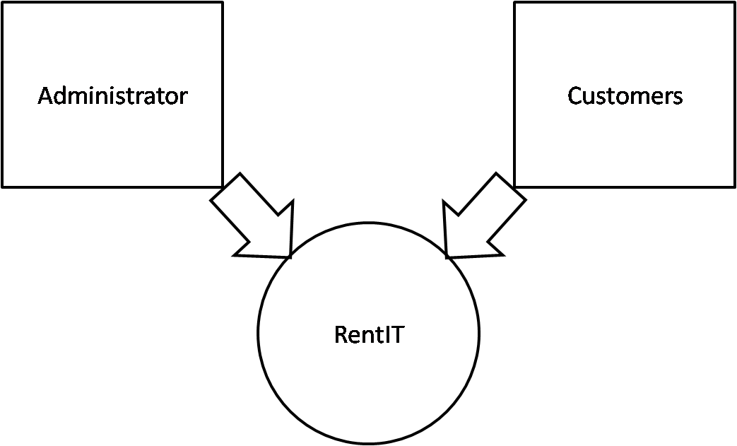

Figure 1: System Structure

# Feasibility

## Customer End

A customer should register and log in to use the full function of this system or he or she can only brose the movies by genres. In the registration part, we add validation to the age of a customer: A customer has to be 18 year old. At the same, phone number and zip code have validation which means the customer needs to register with the valid information. This makes the information safe and valid. Once the customer logs in, the system starts to track his or her information until logging out. This is implemented using session function in PHP.

The customer can browse movies after logging in. The movies are organized by genres. The customer could browse a movie detail like title, genre, description, casting information and year. Here, if the movie is already in his or her queue, the customer cannot add this movie to the queue again.

Search function is also included so that it is convenient to look for a particular movie. The customer inputs the title of a movie or partial title. If there is such a movie or related moves in the repository, a movie list will be displayed.

Queue function manages the list of movies that the customer wants to rent. When browsing a particular movie, the customer could add this movie to his or her queue except this movie is in his or her already. The customer also can delete a movie from the queue.

Movie review part is included. When browsing the movie, the customer could add comments on this movie and view others comments too.

Account management provides the possibility for the customer to change his or her personal information. But the first name, last name and email address cannot be changed for the safety.

# Database Implementation

**E-R Model**

Figure 2: E-R Model

**Relational Model**

CustomerInfo(email:string, password:string,firstname:string,lastname:string,date_of_birth:date, gender:char,address_line1:string,address_line2:integer,city:string,state:string,zipcode:integer, country:string,phone:integer,is_active:char,security_qs:string,security_ans:string)

Movies(movie_id:integer,title:string,release_dt:date,genre:string, num_awards:integer ,awards:strings, num_dvds:integer,rating:real,description:string)

CastCrew(cast_id:integer, name:string,profile:string)

Casting(movie_cast_id:integer,cast_id:integer,movie_id:integer,role:string)

Plan(plan_id:integer,plan_name:string,plan_amt:real,max_dvds:integer,rent_period:integer, validity_months:integer,description:string,is_active:char)

Customer_Plan(email:string,plan_name:string,buy_dt:date,discount_amt:real)

CustomerReview (reviewer: string, movie_id: integer, user_rating: real, comments: string)

CustomerQueue (email:string,movie_id:integer)

Movie_Rent (email:string,dvd_id:integer,rent_dt:date,expected_return_dt:date)

Dvds (dvd_id:integer, movie_id:integer, is_available:char)

Administrator(employee_id:integer, password:string,firstname:string,lastname:string,type:string, security_qs:string,security_ans:string)

# Function Implementation

The system can keep the session information after the customer logs in. By tracking the session, the customer could access to his account and add movies to the queue.

## Customer End

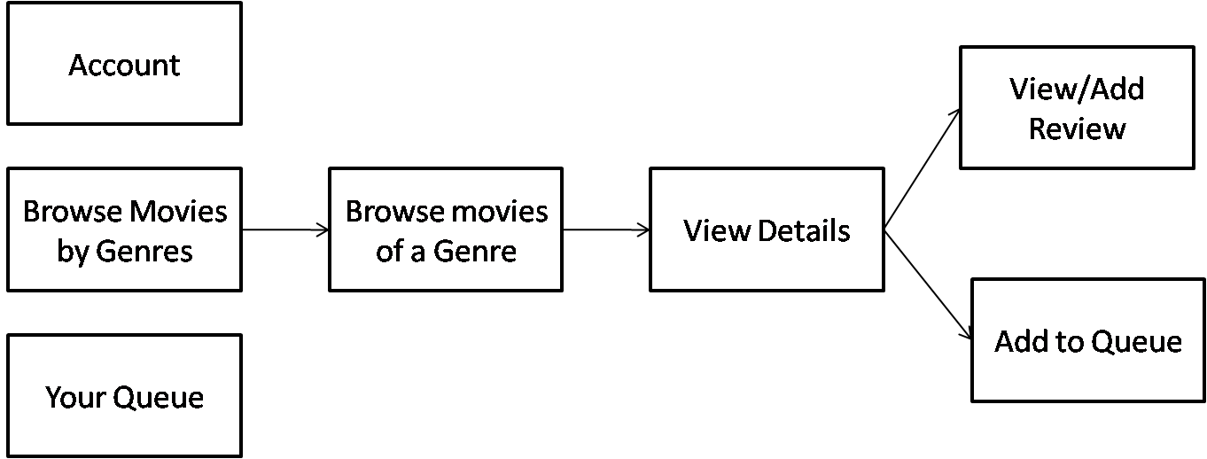

Figure 3: Customer end pages organization

* Browse movies: After logging in, the customer can browse movies by genres.
* Brose movies of the same genre: After clicking ‘More…’ click, the page directs to this page. So all the movies of the same genre are listed in this page.
* View movies’ details: A movie detail page shows up when the customer clicks the ‘view’ button in the previous page.
* Add movie to the queue: In the last page, the customer can add the movie to the queue except this movie is already in the queue.
* Customer account: After logging in to the system the customer can change his/her information. The customer is not allowed to change his/her name, email, and password but the ‘Date of birth’, ‘Gender’, ‘Service Plan’, ‘Address line 1’, ‘Address line 2’, ‘City’, ‘State’, ‘Zip’, ‘Phone Number’, ‘Security Settings Questions’ and ‘Security Settings Answer’.
* Admin menu: In this page admin can find hyperlinks to manage system tools. It has three main menus. Using the links of the movie management part, admin can add movies, view the entire movies, add casting, and view casting. With customer management menu, admin can see all of the customers in the system. With System settings admin can manage service plans.
* View movie details: In movie page is the customer clicks “View Review” then customer can see movie details with the comments of the other customers in this page. If the customer clicks “add review” button, it will convey the customer to “add movie review” page.
* Add movie review: In this page customer can comments a movie.
* Customer registration: The customer can register an account.
* Login page: After validating the password and user name, the system starts tracking the session information of this customer.

## Administrator End

* Service Page: DVD rental system can have multiple service plans. Using this page, administrator can add service plan and can specify details like plan fee, validity month, rent period for which customer is allowed to keep DVD and description of the plan.
* Service Plan: Service Plan page allows customer to add multiple plans for the DVD rental system. Customer can specify plan no specify for how long customer is allowed to keep DVD with him/her, validity month specifies how long this plan customer can have per payment and status of the plan. Plan can be active or inactive. Description field is to add some description of the plan.
* View service plan: This page allows customer to see all the service plans in DVD rental system. Customer can see all the details of plan. On this page customer can update/delete plan.
* View Customer: Here, admin can see the customer registered in DVD rental system. Here admin can put the return date of the DVD which specifies that customer has returned rented DVD to the RentIT.
* Add Movies: The Add Movie page allows the administrator to add a new movie in to his database. This literally specifies the details about the DVD that the company owns. All the details of a movie that a customer might want to know is entered by the administrator in this page, apart from the details on the casts of a particular movie.
* Add Casting: The Add Casting page allows the administrator to add details about the casts of a movie. The different casts of a movie is added in this page
* Cast and Crew: The cast and Crew page allows the administrator to enter the overall cast. This is not restricted to a movie; it’s the overall casts that are present in the film industry. These details are then reflected in the ‘add casting page’, to select a cast for a particular movie.
* Manage Movies: This allows the administrator to edit, delete the details about a movie based on the movie id of a movie.
* Manage Casts: The administrator can manage the casts of a movie, that is he can edit the role of a cast , in case if he had added it wrongly when he is adding a cast using the add casting page.
* Manage Cast and Crew: The overall cast and crew can be edited or deleted by the administrator using this page.

# Evaluation